Caleb Hayden

CIS 310-01

Assignment 6

Due 10/12/17

1. Draw the dependency Diagram.

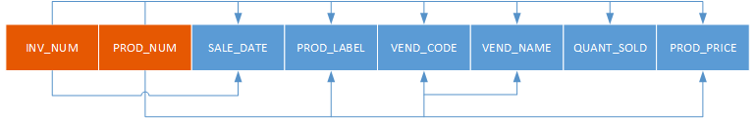

1. Is the table in 1NF? Why or why not?

The table is in 1NF because each row in the table is unique.

1. Is the table in 2NF? Why or why not? If the table is not in 2NF, normalize the table so that the resulting database is in 2NF.

The Database is not yet in 2NF because several partial dependencies exist. These partial dependencies should become separate tables as seen below.



1. Is the database above in 3NF? Why or why not? If it is not 3NF, normalize the table so that the resulting database is in 3NF.

The table is not yet in 3NF because a transitive dependency exists between VEND_CODE and VEND_NAME.



1. Use the resulting tables in step 4 to create a Crow's Foot ERD.

